**The Social Institutions and Gender Index (SIGI)**

**What is the SIGI?**

The OECD Development Centre’s Social Institutions and Gender Index (SIGI) is a unique cross-country measure of gender-based discrimination in social institutions. The SIGI is comprised of three main components: i) country profiles containing comprehensive qualitative information on legal, cultural, and traditional laws and practices that discriminate against women and girls; ii) the Gender, Institutions and Development Database comprising indicators on gender discrimination in social institutions; and iii) the Index classifying countries according to their level of discrimination in social institutions.

**The SDG Goal 5.1.1**

Through a technical cooperation with UNWOMEN and the World Bank, the OECD’s **Social Institutions and Gender Index (SIGI)** is an **official data source** tracking progress on **SDG 5.1.1**.

‘***Whether or not legal frameworks are in place to promote, enforce and monitor equality and non-discrimination on the basis of sex’.***

SIGI provides data on legal frameworks within the three indicators of Discrimination in the Family, Civil Liberties and Physical Integrity.

**What are discriminatory social institutions?**

Formal and informal laws, social norms and practices that restrict or exclude women and girls, and consequently curtail their access to rights, justice, empowerment opportunities and resources.

**What is the SIGI’s added value compared to existing gender-specific measures?**

Existing gender indicators commonly focus on gender inequalities in key economic and social indicators, like education or employment. To complement these existing measures, the SIGI focuses on the underlying factors driving gender inequalities: discriminatory social institutions. The SIGI’s indicators address both *de jure* and *de facto* situations of discrimination against women. Indeed, in some countries, while the legal framework protects women’s rights, lack of implementation and discriminatory social norms can lead to persistent discriminatory practices.

**What is the composition of the SIGI 2018?**

The SIGI was first launched in 2009 followed by a second version in 2014. The next edition of the SIGI will be launched in November 2018. New additions and developments will include extension of the country coverage to over 180 countries, new indicators such as workplace discrimination and access to justice, revised conceptual and methodological frameworks and update of country profiles and data in order to offer more comprehensive information to the development community.

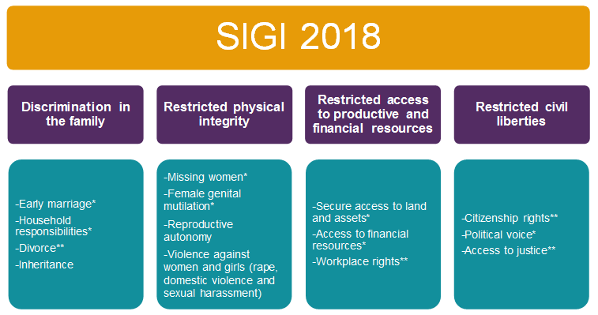The SIGI covers four dimensions, spanning major socio-economic areas that affect the life course of a girl and a woman. The discrimination in the familysub index captures social institutions that limits women’s decision-making power and undervalues their status in the household and the family. The restricted physical integrity sub index captures social institutions that limit women’s and girls’ control over their bodies, increase their vulnerability to a range of forms of violence. The restricted access to productive and financial resources sub index captures discrimination in women’s rights that have negative impacts on women’s opportunities for economic empowerment. The restricted Civil Liberties sub-index captures discriminatory laws and practices restricting women’s access to, participation and voice in the public and social spheres.

Note: * modified variables;

** new variables

**How can SIGI help countries achieve SDG 5?**

The SIGI has already contributed to improving policies targeting gender equality and women’s empowerment at the global, regional and national levels. The SIGI remains the only global database on discriminatory social institutions and offers vital new evidence and perspectives on emerging topics on gender and development.

At the global level, the OECD Development Centre’s Social Institutions and Gender Index is collecting data under the goal 5.1.1 of the Sustainable Development Goals.

At the regional level, SIGI Regional reports have provided detailed analysis of how discriminatory social institutions affect regional development, and offer pathways for governments to maximise the multiple benefits of gender equality for their development strategies.

At the national level, the two country studies in Uganda and Burkina Faso have been developed and constitute a ‘’compass for achieving SDG 5’’. This analysis was undertaken adapting the global SIGI framework to national specificities to produce unique new data on discriminatory social institutions at the sub-national level and assist the design of recommendations to support more effective policies to tackle the root causes of gender inequality.